

Lab 14: Manage access with RBAC

At the end of each lab, any resources you created in your account will be preserved. Some Azure resources, such as VM instances, may be automatically shut down, while other resources, such as storage services will be left running. Keep in mind that some Azure features cannot be stopped and can still incur charges (i.e. Azure Bastion). To minimize your costs, delete all resources and recreate them as needed to test your work during a session.



Reference: AZ-900T0X-MICROSOFTAZUREFUNDAMENTALS

14 - Manage access with RBAC

In this walkthrough, we will assign roles and view activity logs.

# Task 1: View and assign roles (5 min)

In this task, we will assign the Virtual machine contributor role.

1. Sign in to the [Azure portal](https://portal.azure.com/) with your **odl_user_xxx** azure account
2. From the **All services** blade, search for and select **Resource groups**, then click **+ Create**.
3. Create a new resource group. Click **Create** when you are finished.

| Setting | Value |
| --- | --- |
| Subscription | **Choose your subscription (you should see “Seneca College : <course name>”)** |
| Resource group | **myRGRBAC** |
| Region | **(US) East US** |
|  |  |

1. Create **Review + create** and then click **Create**.
2. **Refresh** the resource group page and click the entry representing the newly created resource group.
3. Click on the **Access control (IAM)** blade, and then switch to the **Roles** tab. Scroll through the large number of roles definitions that are available. Use the Informational icons to get an idea of each role’s permissions. Notice there is also information on the number of users and groups that are assigned to each role.

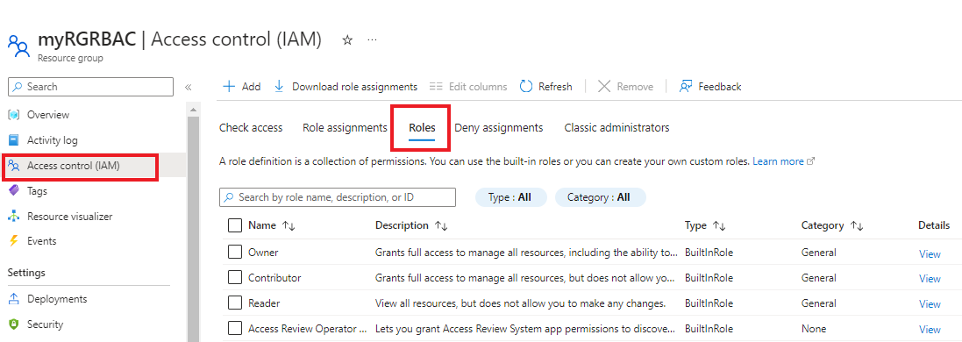

1. Switch to the **Role assignments** tab of the **myRGRBAC - Access control (IAM)** blade, click **+ Add** and then click **Add role assignment**. Assign the *Virtual Machine Contributor* role to your user account, then click **Save**.

| Setting | Value |
| --- | --- |
| Role | **Virtual machine contributor** |
| Assign access to | **user, group, or service principal** |
| +Select Members | your *odl_user_xxx* user account |
|  |  |

1. **Note:** The Virtual machine contributor role lets you manage virtual machines, but not access their operating system or manage the virtual network and storage account they are connected to.

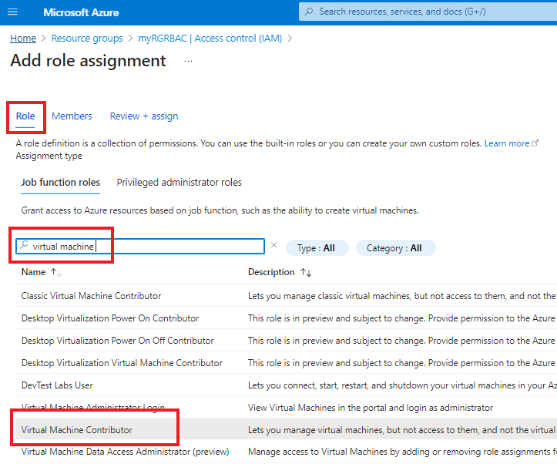

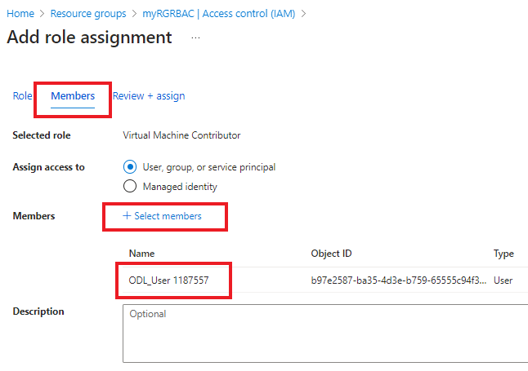

1. **Click Review + assign**
2. **Refresh** the Role assignments page and ensure you are now listed as a Virtual machine contributor.

**Note**: This assignment does not actually grant you any additional provileges, since your account has already the Owner role, which includes all privilges associated with the Contributor role.

# Task 2: Monitor role assignments and remove a role

In this task, we will view the activity log to verify the role assignment, and then remove the role.

1. On the myRGRBAC resource group blade, click **Activity log**.
2. Click **Add filter**, select **Operation**, and then **Create role assignment**.

[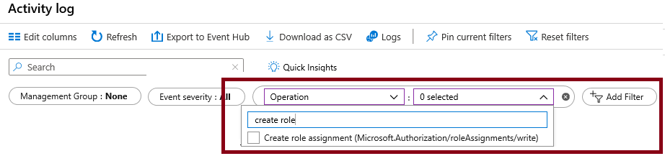](https://microsoftlearning.github.io/AZ-900T0x-MicrosoftAzureFundamentals/Instructions/images/1503.png)

1. Verify the Activity log shows your role assignment.

**Note**: Can you figure out how to remove your role assignment?

Congratulations! You have assigned roles and viewed activity logs.

**Note**: To avoid additional costs, you can remove all resources in the resource group. Search for resource groups, click your resource group, and then delete the resources within the resource group. **DO NOT DELETE YOUR RESOURCE GROUP.**

# Submission Requirements

Submit a screenshot with the following information:

**Screenshot #1:**

* Results of a filter applied on the Activity logs
* The Azure Portal with your **CloudLab Account** [requires another browser window]
  + **Note**: underline the above items as described in the below picture

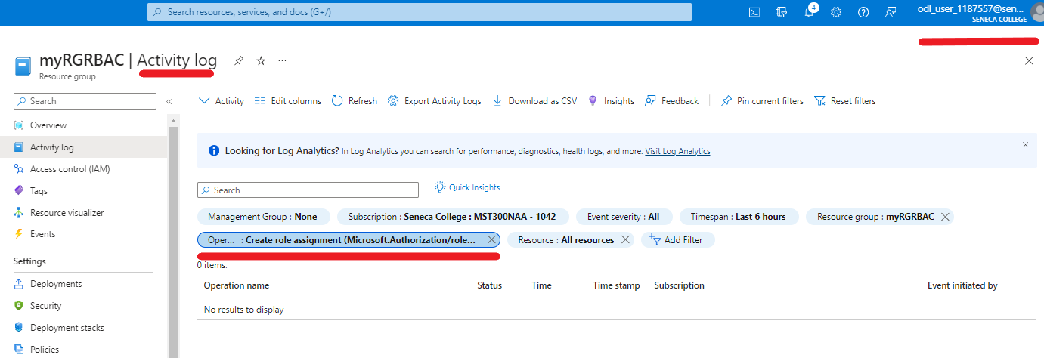

**Screenshot #2:**

* Successful deletion of resources within resource group. **DO NOT DELETE YOUR RESOURCE GROUP!**

